**F. Y. B. Tech** **Academic Year 2024-25**

**Semester: I Subject: Multisim Lab** **Name:** Akhshat Kampassi **Division:** 21

**Roll No:**1262243592 **Batch:** 3

**Experiment No: 2**

**Name of the Experiment:** Implementation of half wave and full wave bridge rectifier using rectifier diodes like 1N400X series.

**Performed on:** 29th August, 2024

**Submitted on:**

**Theory:**

In Half Wave Rectification, When AC supply is applied at the input, only Positive Half Cycle appears across the load whereas, the negative Half Cycle is suppressed. How this can be explained as follows:

During positive half-cycle of the input voltage, the diode D1 is in forward bias and conducts through the load resistor RL. Hence the current produces an output voltage across the load resistor RL, which has the same shape as the +ve half cycle of the input voltage.

During the negative half-cycle of the input voltage, the diode is reverse biased and there is no current through the circuit. i.e., the voltage across RL is zero. The net result is that only the +ve half cycle of the input voltage appears across the load. The average value of the half wave rectified o/p voltage is the value measured on dc voltmeter.

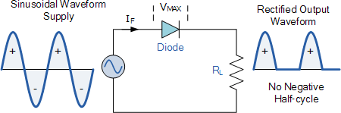

The full wave rectifier converts both halves of each waveform cycle into pulsating DC signal using four rectification diodes. In the previous power diodes tutorial we discussed ways of reducing the ripple or voltage variations on a direct DC voltage by connecting smoothing capacitors across the load resistance. Like the half wave circuit, a full wave rectifier circuit produces an output voltage or current which is purely DC or has some specified DC component. Full wave rectifiers have some fundamental advantages over their half wave rectifier counterparts. The average (DC) output voltage is higher than for half wave, the output of the full wave rectifier has much less ripple than that of the half wave rectifier producing a smoother output waveform.

The type of circuit that produces the output waveform in both cycles of AC waveform, is that of the **Full Wave Bridge Rectifier**. This type of single phase rectifier uses four individual rectifying diodes connected in a closed loop “bridge” configuration to produce the desired output.

The main advantage of this bridge circuit is that it does not require a special centre tapped transformer, thereby reducing its size and cost. The single secondary winding is connected to one side of the diode bridge network and the load to the other side as shown below.

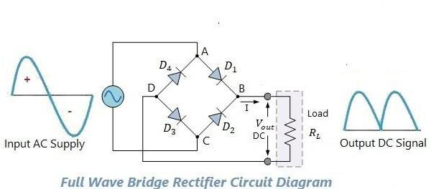

**Theoretical Calculations:**

Vrms = Vm / 2 Vm = 2Vrms Vdc = Vm / π

**Activity:**

Using following components

1. Diode (1N400X series)
2. Transformer (Single phase, 50 Hz, 230 V/10V)
3. Resistor (1 kΩ)
4. Capacitor (470 μF)
5. AC and DC ammeter
6. AC and DC voltmeter
7. Create model of half wave rectifier using diode of series 1N400X. Simulate it and observe input and output waveforms. Attach screenshots of your model and results.
8. Create model of full wave bridge rectifier diode of series 1N400X. Simulate it and observe input and output waveforms. Attach screenshots of your model and results**.**

**Procedure:**

1. Create a model as per circuit diagram.
2. Measure AC voltage (Vrms) across secondary of transformer.
3. Measure DC voltage (VDC) across the output.
4. Observe AC and DC voltage waveforms.

**Observations:**

| **Sr.**  **No.** | **Applied**  **Voltage (Vrms)** | **Observed Output Voltage**  **(Vdc)** | **Calculated Output Voltage**  **(Vdc)** |
| --- | --- | --- | --- |
| 1 | 230 |  |  |
| 2 | 230 |  |  |

**Half Wave Rectifier**

Circuit Diagram -

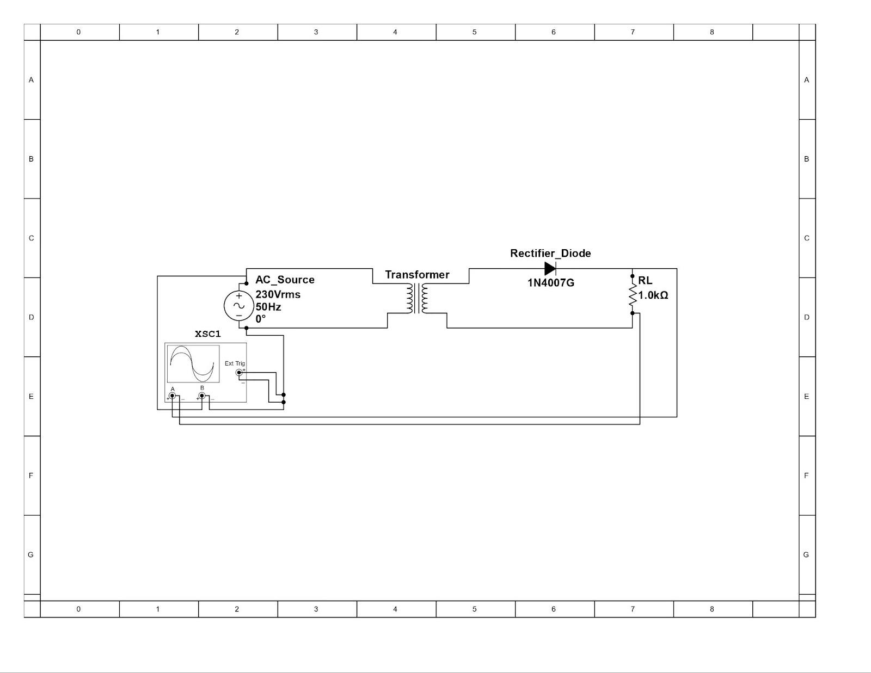

Oscilloscope Reading -

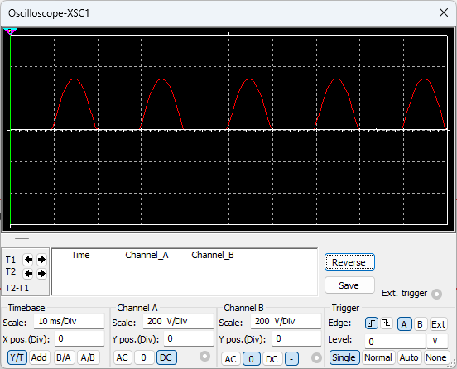

Calculating ripple factor -

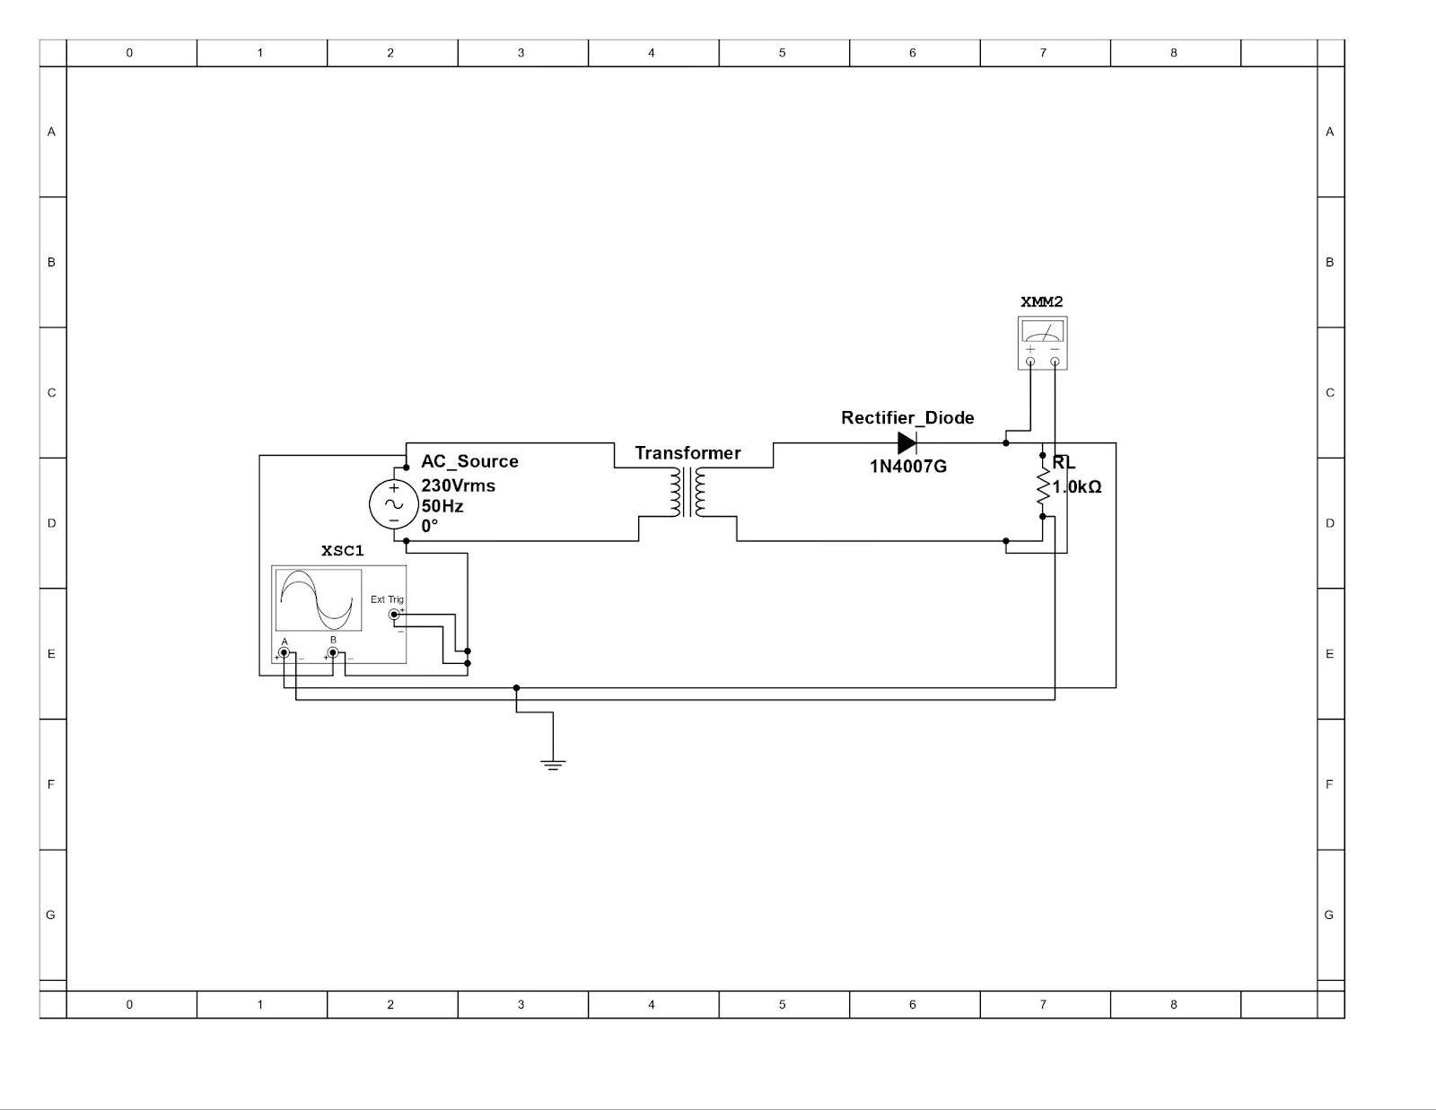

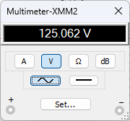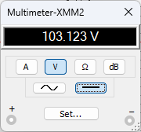

$\frac{Vac}{Vdc}=\frac{125.062}{103.123}=1.2127459442$

Reversing Diode Orientation -

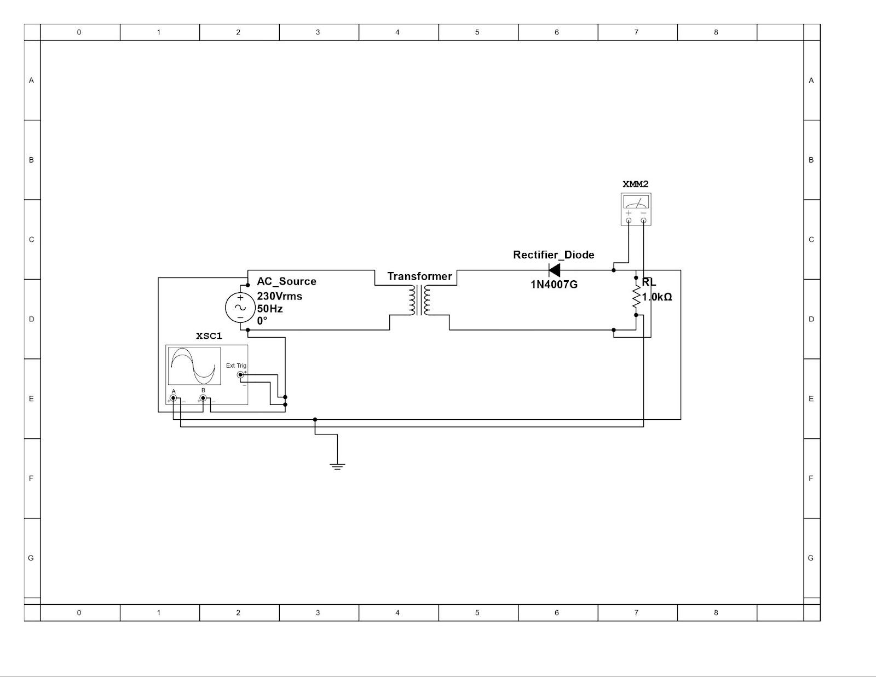

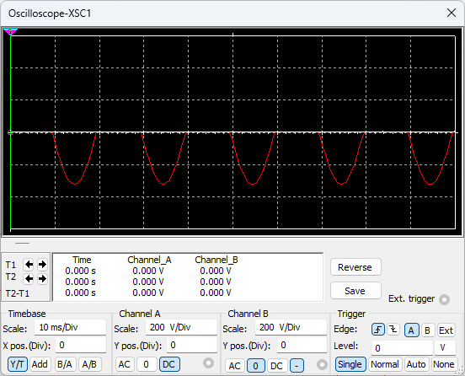

**Full Wave Rectifier**

Circuit Diagram -

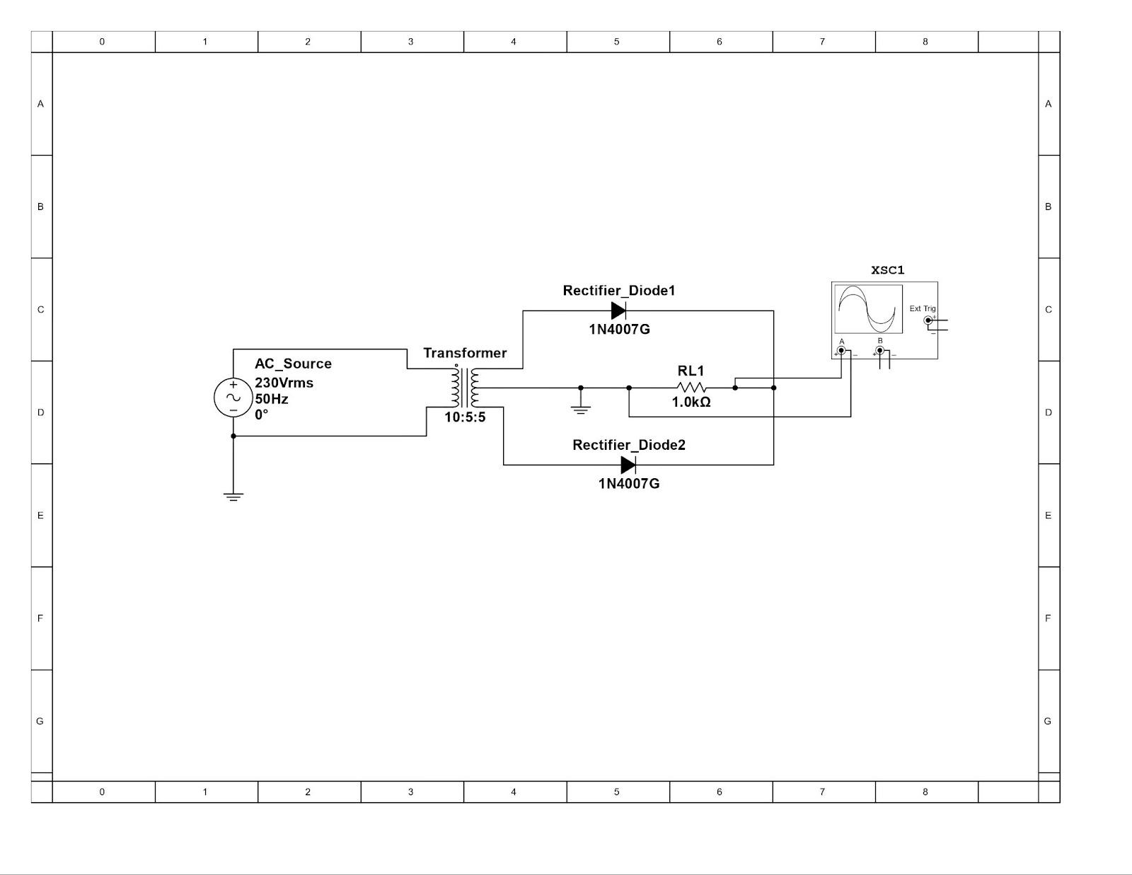

Oscilloscope Reading -

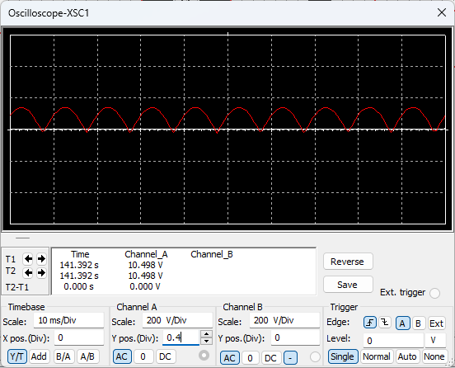

Calculating ripple factor -

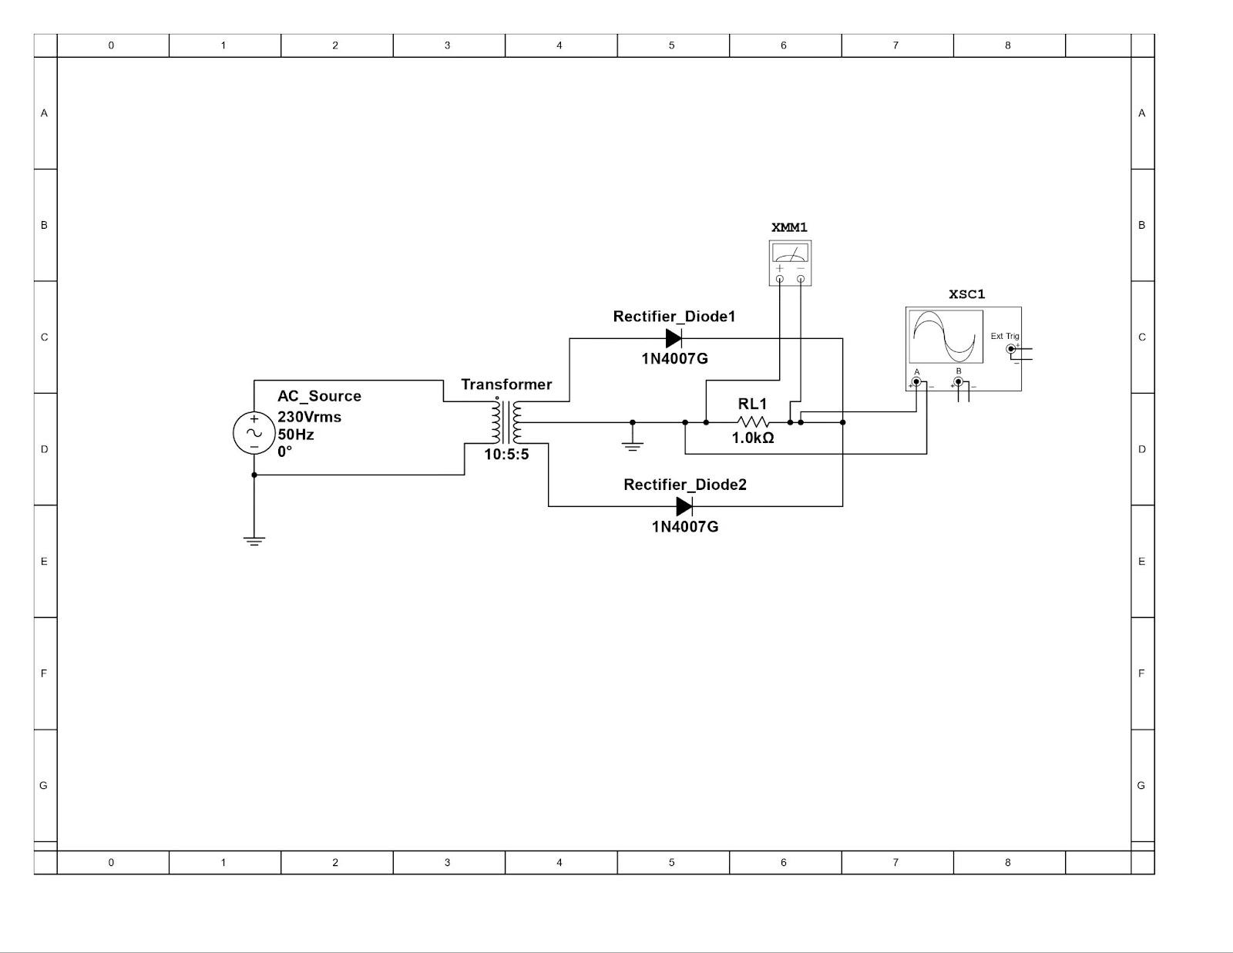

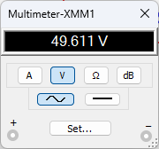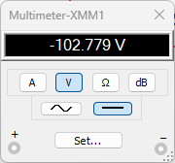

$\frac{Vac}{Vdc}=\frac{49.611}{102.779}=0.04803641437$